
Tres Chic
Tres Chic
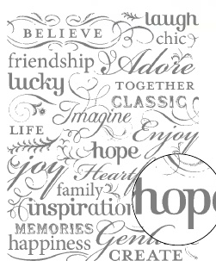

-----------------------------------------------------------------------------------------------------
109258
1
Set of

