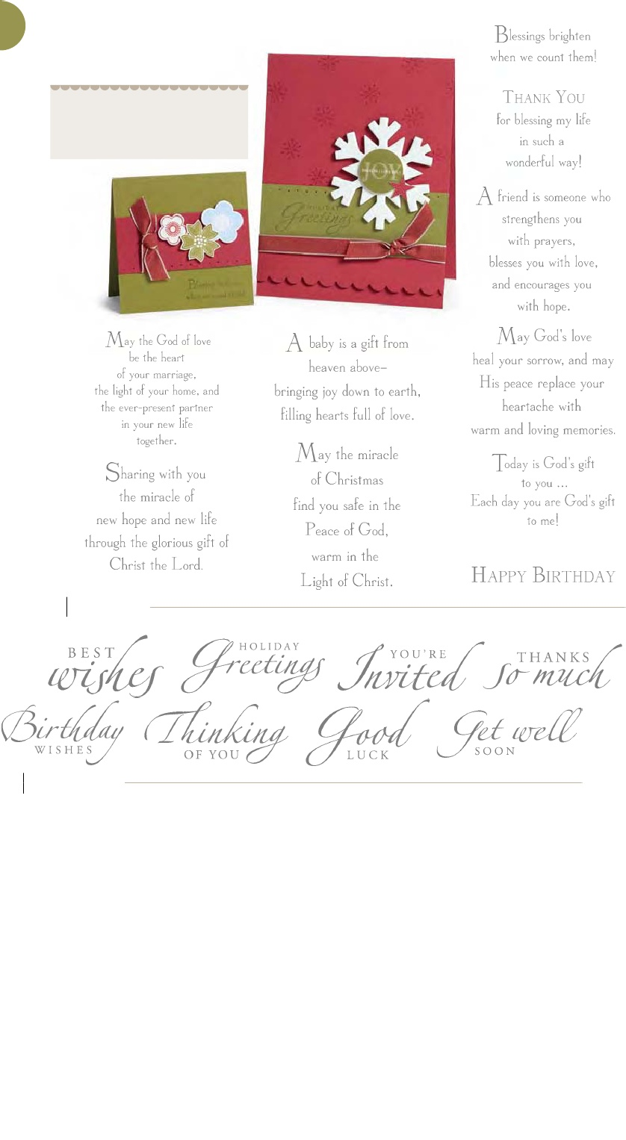

God’s Blessings
God’s Blessings

-----------------------------------------------------------------------------------------------------
107373
8
Set of

